Writing practice
Preparation
There are mistakes in every sentence, correct them and write the sentences on the line.
1. I send 25 massages every day.
_________________________________________________________________
2. His favorit sport is teenis.
_________________________________________________________________
3. Can I borow your bycicle?
_________________________________________________________________
4. The whether in my town is usually wet and windy.
_________________________________________________________________

Have a look at this email and answer the questions.
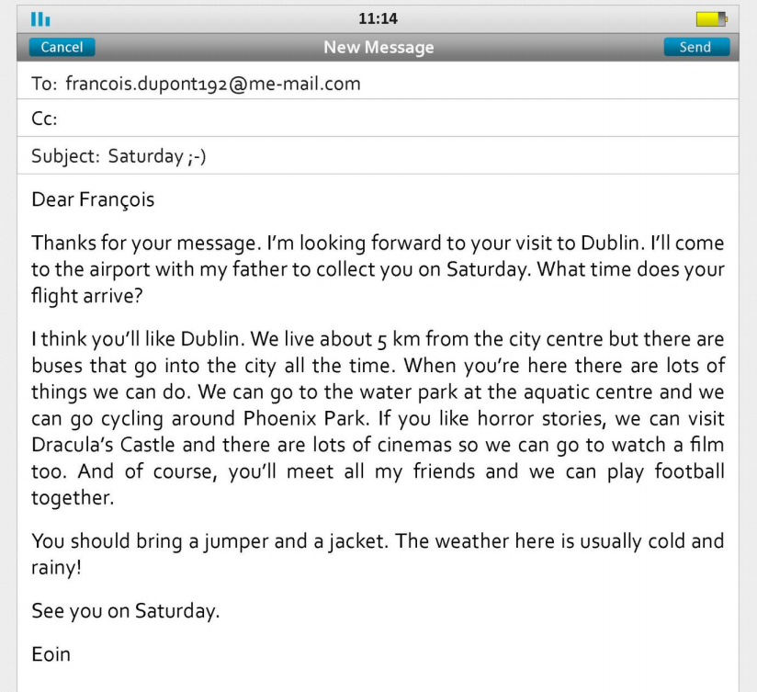
Questions:
1. Check your understanding: true or false
1. Eoin will go to the airport alone to meet François. True False
2. Eoin is meeting François on the weekend. True False
3. Eoin lives in the centre of Dublin. True False
4. There are lots of places to visit and many things to do in Dublin. True False
5. Eoin and his friends like to play sports. True False
6. Dublin is a good place to visit if you like scary movies. True False
2. Check your writing: spelling
Read François reply and correct the spelling mistakes in his email. In total, there are 4 mistakes.
Dear Eoin
Thanks for your mesage. I’m really looking forward to my visite to Dublin. My aerplane arrives at 15:30.
I would like to go to the water park and Phoenix Park. Is it posible to borrow a bycicle? I’m not very intrested in Dracula but I like films so we can go to the cinema too. I want to meet your frends and your familly. I love footbal. It’s my favorite sport so we can play every day if you want!
See you on Saturday.
François

3. A friend from a different country is coming to visit you next month. Write an email to them.

Paragraph 1: Say that you’re looking forward to your friend’s visit. Say you’ll meet him/her at the airport.
Paragraph 2: Describe your city. Say where you live. Say where you’ll take your friend.
Paragraph 3: Tell your friend what clothes to bring and what the weather will be like.
Write a letter of 100 to 150 words.
Write your letter here:

